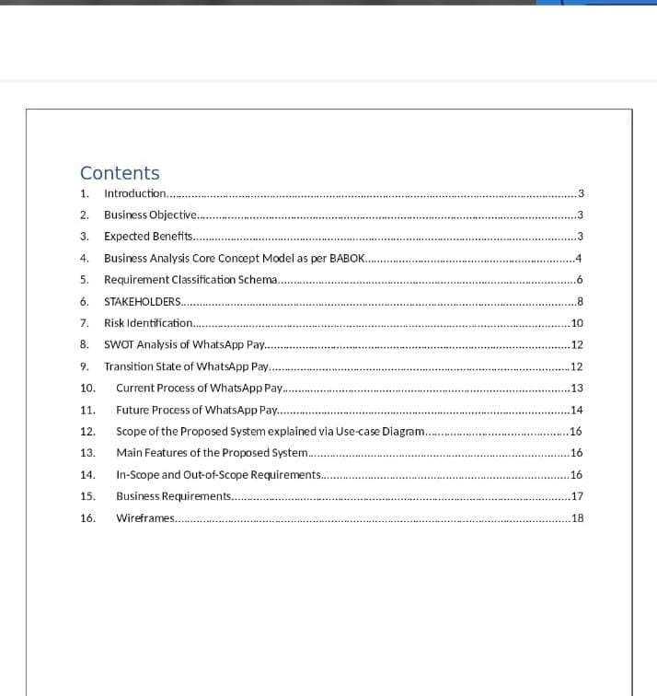

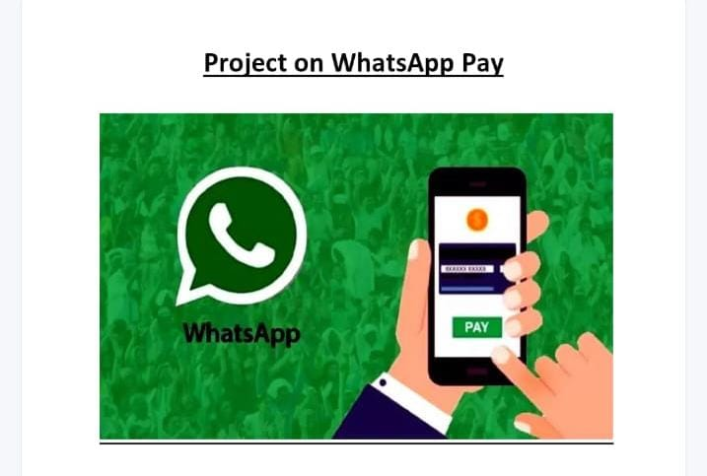

1.

Introduction

WhatsApp is a messaging and Voice over IP (VoIP) service owned by Facebook. It allows users to

send text and voice messages, make voice and video calls, and share images, documents, and other

media. WhatsApp runs on mobile devices but is also accessible from desktop computers. WhatsApp

has over 2 billion users worldwide as of today. It has become the primary means of electronic

communication in multiple countries across multiple continents, including Latin America, the Indian

subcontinent, and large parts of Europe and Afric

**1.Introduction**

WhatsApp is a messaging and Voice over IP(VoIP) service owned by Facebook. It allows users to send text and voice messages, make voice and video calls, and share images, documents, and other media. WhatsApp runs on mobile devices but is also accessible from desktop computers. WhatsApp has over 2 billion users worldwide as of today. It has become the primary means of electronic communication in multiple countries across multiple continents, including Latin America, the Indian subcontinent, and large parts of Europe and Africa.

1.

Introduction

WhatsApp is a messaging and Voice over IP (VoIP) service owned by Facebook. It allows users to

send text and voice messages, make voice and video calls, and share images, documents, and other

media. WhatsApp runs on mobile devices but is also accessible from desktop computers. WhatsApp

has over 2 billion users worldwide as of today. It has become the primary means of electronic

communication in multiple countries across multiple continents, including Latin America, the Indian

subcontinent, and large parts of Europe and Africa.

2.

Business Objective

WhatsApp has decided to take the plunge into this digital payment market. They have launched a

new feature namely, WhatsApp Payments to be known as WhatsApp Pay in Brazil in June 2020.

WhatsApp promises to disrupt the global digital payments ecosystem with WhatsApp Pay.

WhatsApp will integrate the customer’s debit card or credit card into their app. That is, while

chatting with your peers, you can transfer the money to them. There will be no separate app that the

customers need to download to access this payment feature. This feature would be provided to

users as an update in the existing WhatsApp messaging app. The user can use WhatsApp pay feature

by updating the WhatsApp messaging app.

**2.Business Objective**

WhatsApp has decided to take the plunge into this digital payment market. They have launched a new feature namely, WhatsApp Payments to be known as WhatsApp Pay in Brazil in June 2020.WhatsApp promises to disrupt the global digital payments ecosystem with WhatsApp Pay. WhatsApp will integrate the customer’s debit card or credit card into their app. That is, while chatting with your peers, you can transfer the money to them. There will be no separate app that the customers need to download to access this payment feature. This feature would be provided to users as an update in the existing WhatsApp messaging app. The user can use WhatsApp pay feature by updating the WhatsApp messaging app.

**Business Objective by senior management:**

1. Have at least 1 million users use WhatsApp pay feature within the first 3 months of launch
2. Over 1 year of its launch have 30% of user base using WhatsApp pay.

**Expected Benefits**

1. Easy peer to peer payments: You can send money to your family, friends or relatives all through WhatsApp.

2. Users need not go to the bank or use wallets, bank apps, or NEFT to transfer money.

3. It will be a one-click payment.

4. Easy and user-friendly interface of WhatsApp would make digital payments seamless and there will be no need to enter details at multiple page loads

1. **Business Analysis Core Concept Model as per BABOK**

Business Analysis Core Concept Model™ (BACCM™): defines a conceptual framework for the business analysis profession.

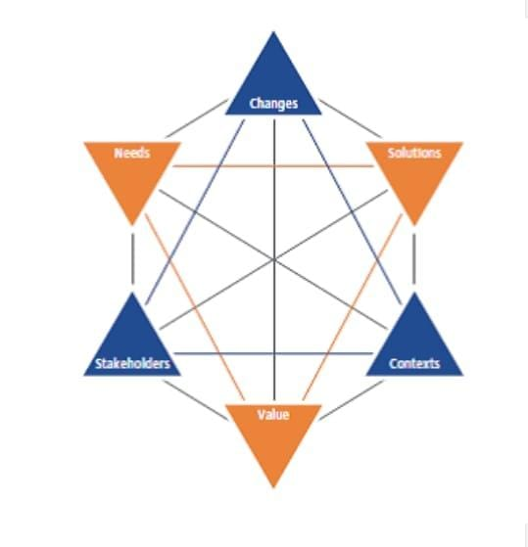

**Figure 1. Business Analysis Core Concept Model as per BABOK**

For WhatsApp to come up with Digital Payments in their existing application, detailed analysis pertain to below aspects will have to be done.

1.Need to come up with new feature

2.Change required in to satisfy the need

3.Solution to be delivered in response of change and need

4.Stakeholders impacted by the solution delivered in response of change and need

5.Value to the stakeholder for the solution delivered

6.Context of payments horizon in which the solution will be delivered enhancing the value of the application to the stakeholders.

**1.1.BACCM for WhatsApp**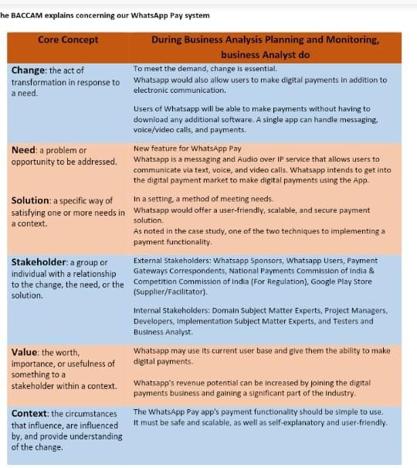

**5.Requirement Classification Schema**

**Requirements are described by following classification schema:**

**5.1.** **Business Requirements:** These are statements of goals, objectives, and outcomes that describe why a change has been initiated. They can apply to the whole of an enterprise, a business area, or a specific initiatives.

**5.2. Stakeholder Requirements:** It describe the needs of stakeholders that must be met to achieve the business requirements. They may serve as a bridge between business and solution requirements.

**5.3. Solution Requirements**: It describe the capabilities and qualities of a solution that meets the stakeholder requirements. They provide the appropriate level of detail to allow or the development and implementation on the solution. Solution requirements can be divided into two sub-categories: Functional requirements & Non-functional requirements or quality of service requirements

**5.4. Transition Requirements**: It describe the capabilities that the solution must have and the conditions the solution must meet to facilitate transition from the current state to the future state, but which are not needed once the change is complete.

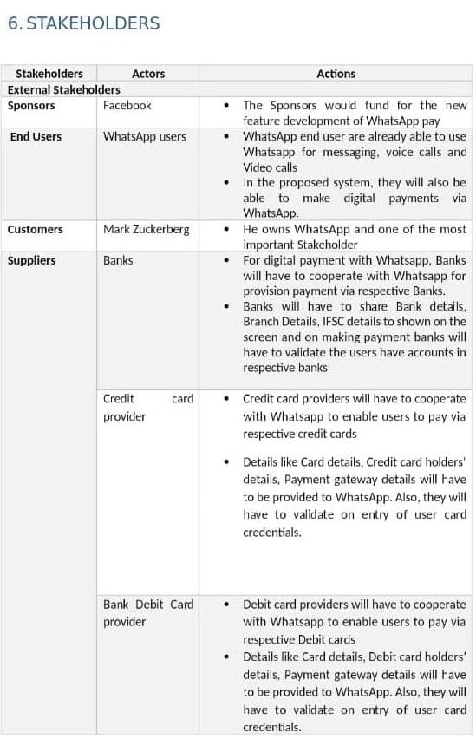

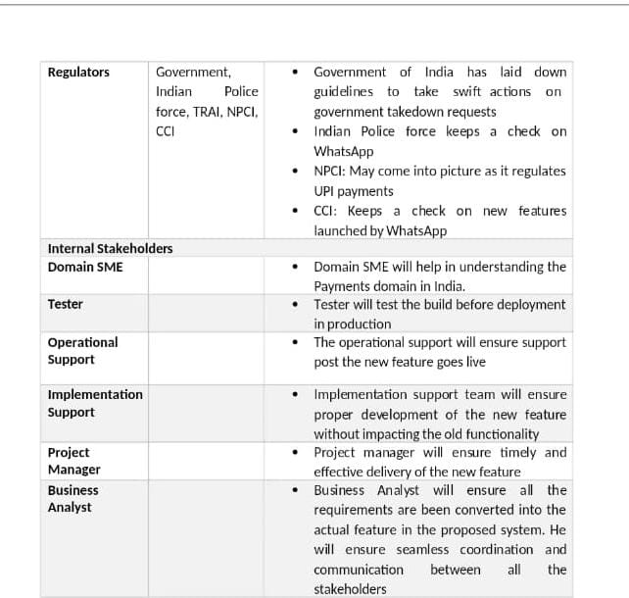

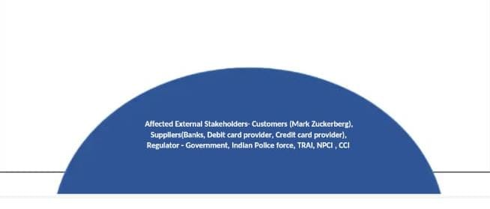

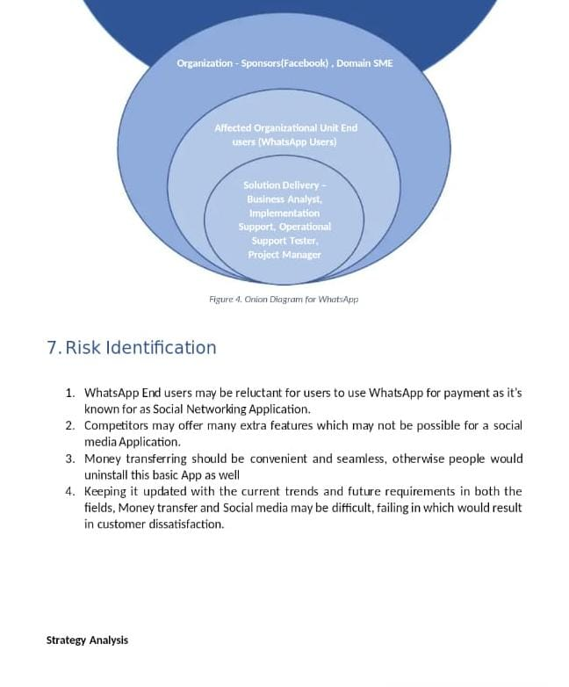

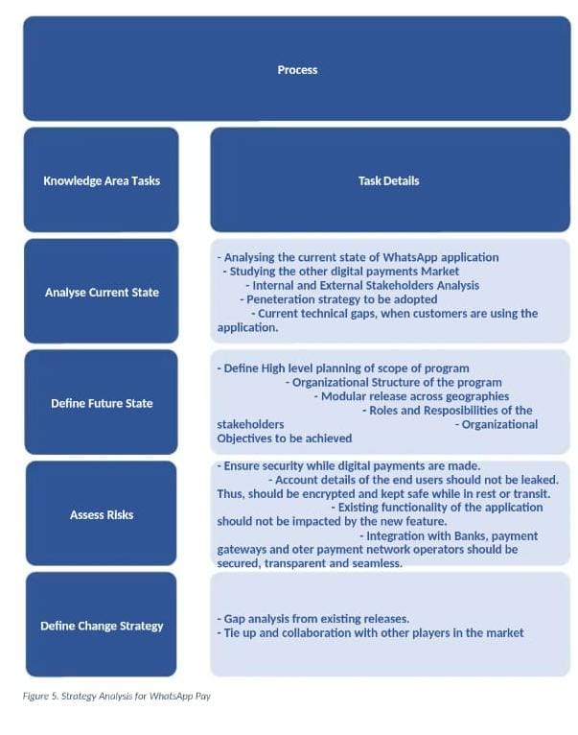

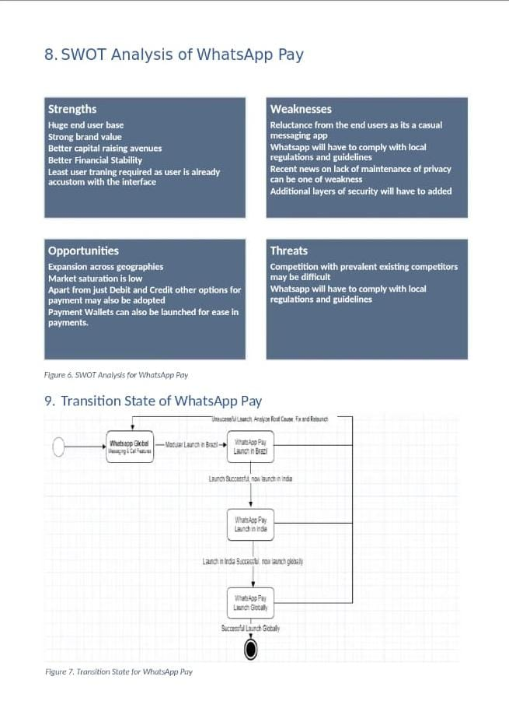

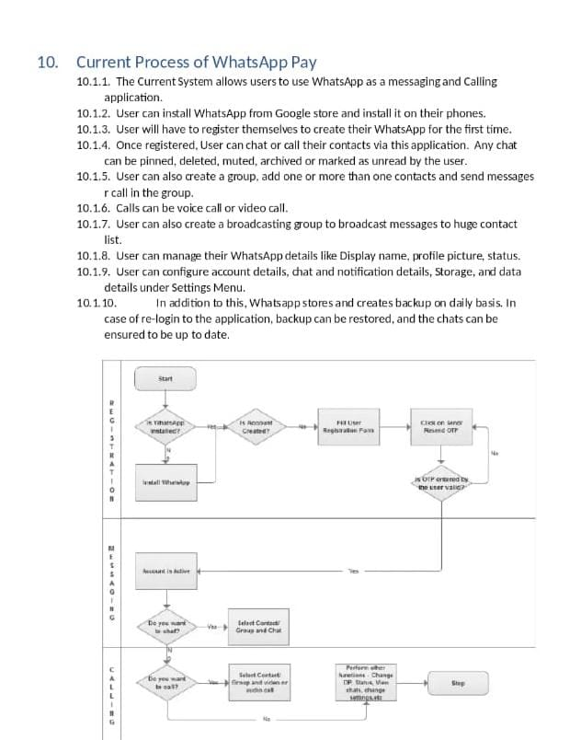

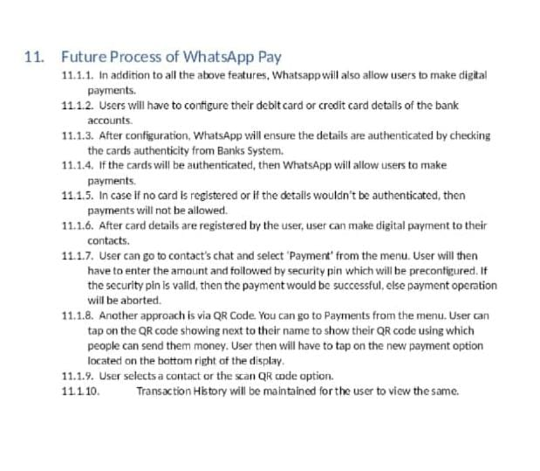

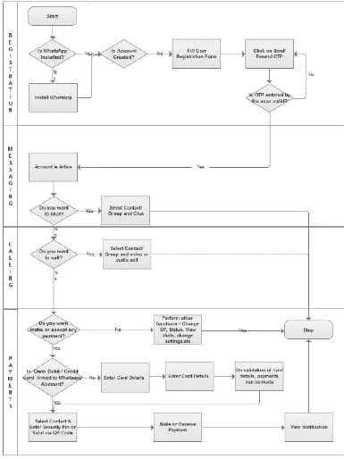

**Scope of the Proposed System explained via Use-case Diagram**

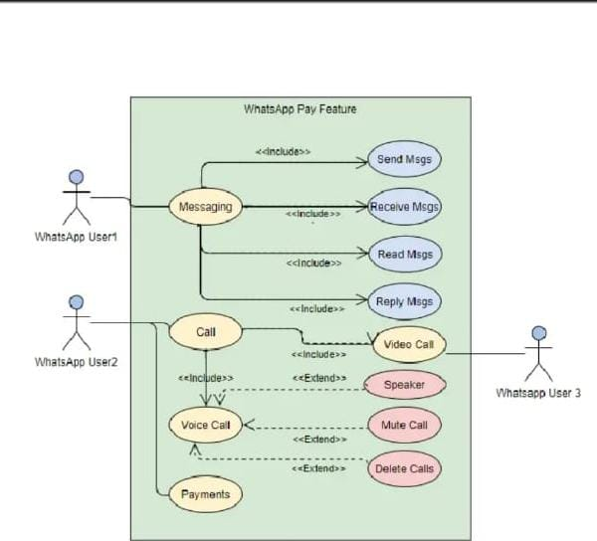

**13. Main Features of The Proposed System**

**1- Proposed system will ensure easy peer to peer payments. User can send money to family, friends, or relatives all through WhatsApp.**

**2-Users need not to go to the bank or use wallets, bank apps or NEFT to transfer money.**

**3-It will be a one- click payment.**

**4-Easy and user-friendly interface of WhatsApp would make digital payments seamless and there will be no need to enter details at multiple page loads.**

**14. In Scope and Out of Scope Requirements**

1. **In Scope Requirements**
2. Addition of bank account to WhatsApp user account.
3. Linkage of Debit & Credit Cards to WhatsApp user accounts
4. Additional credentials management making Digital payment.
5. Payment of receipts of funds to/from contacts via WhatsApp digital payments.
6. Notification of payments/Receipts of transaction done via WhatsApp pay.
7. Digital payments through QR code.
8. Integration with Banks, Payment system operators and payment gateways for seamless transfer of funds.
9. Payments process to follow local & global Guidelines & protocol for secure transactions.
10. Payment feature would be available in multiple languages.
11. Displayof transaction history will be available to the user.
12. **Out of Scope requirements**
13. WhatsApp pay will not be accessible to user who don’t have WhatsApp account.
14. Payment would not be allowed for users Whose bank accounts are not added.
15. WhatsApp wallet is currently out of Scope**.**

**15. Business Requirements :**

1. **Functional Requirements:**
2. **Linkage of debit card/ or credit card to WhatsApp account:** System will allow WhatsApp user to add their bank accounts by providing the option to configure their account from settings.

User can go to payment account detail sub menu under setting Menu.

1. In payment account details user can view his/her debit and or credit card details if already added to the system. User can remove their card details if they wish to.
2. To add new card details, user can click on add and can fill in all the details on the from like account holder name, Account no, IFSC code and card validity period**.**
3. All the details entered by user would then be sent to bank’s systems to validate and authenticate the card details entered by the user. On fetching authentication on the same, user card then will be linked to WhatsApp user account.
4. User can make digital payments only if there is atleast one authentic card linked to their WhatsApp account. Moreover, the transfer can only be done to the contacts of the WhatsApp user.
5. **Process of payment made to and from WhatsApp user account:** There can be two approaches for making digital payments**.**
6. **Approach 1:**

**1.**To use WhatsApp pay feature the user needs to have a bank account with its debit card or a credit card.

1. User shall select the person the want to send money to from their WhatsApp contact list.
2. User shall click on payments option in their chat settings.
3. User shall enter the amount they wish to transfer.
4. User will then enter a security pin.
5. User will click on the transfer button.
6. Money is transferred.
7. The sender and the receiver will both receive a payment notification on their chat window once the fund transfer has been made.
8. In cases where the user is requesting money, tap on request and wait for the person to accept the request.

10.The feature should be available in multiple language.

1. **Approach 2 :**
2. User goes on the main page of WhatsApp and opens the payment option.
3. User then taps on the QR code showing next to their name to show their QR code using which people can send them money.
4. User taps on the new payment option located on the bottom right of the display.
5. User select a contact or scan QR code option.
6. The rest of the process remains the same as above.
7. **Transaction History:** User will be able to view their transaction history.

**2.Non-Functional Requirements :**

1. The system should be scalable to cater to more users when launched in modular manner.
2. The system should be secure. All the transaction details should be encrypted to ensure that data at rest and in motion is secured.
3. Performance of the system irrespective of number of users using the system should be under acceptable limits.

16. Wireframes

Below is the screen when user click on payments Menu. From this screen, users can add their Debit or Credit Cards.

